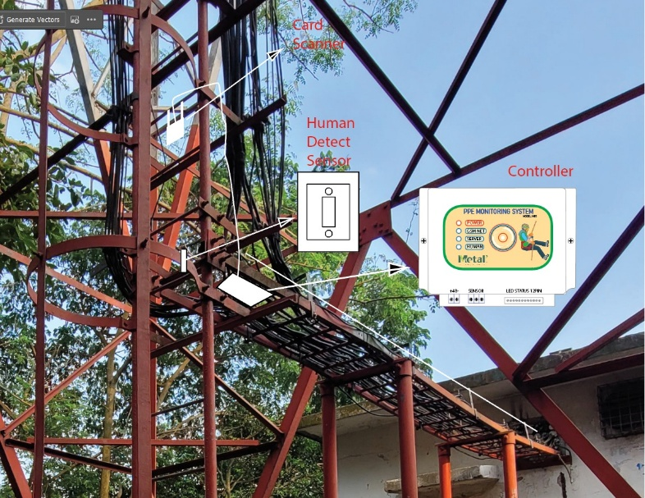
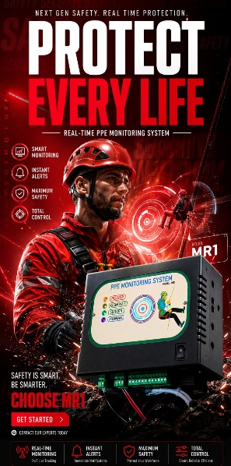
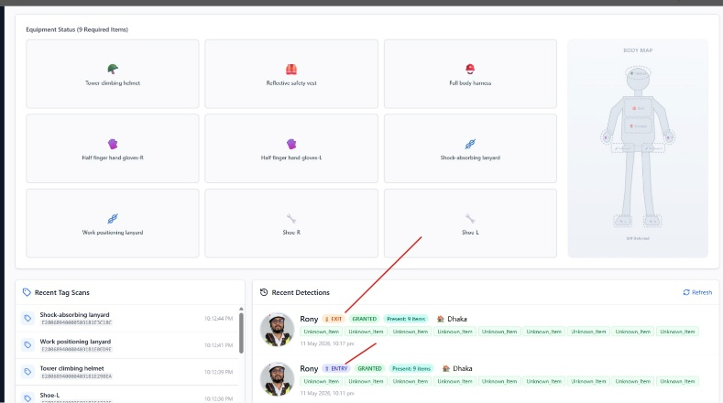

PPE Monitoring System- MR1
Key Features:
1. Employee tower Climbing tracking, if he equipped with appropriate PPE or not.
2. Tower climber current status (Who is working at tower and who is already climbed down)
3. PPE inventory management (Life cycle management)

Digital Signage System-V1
HSSE content visualization
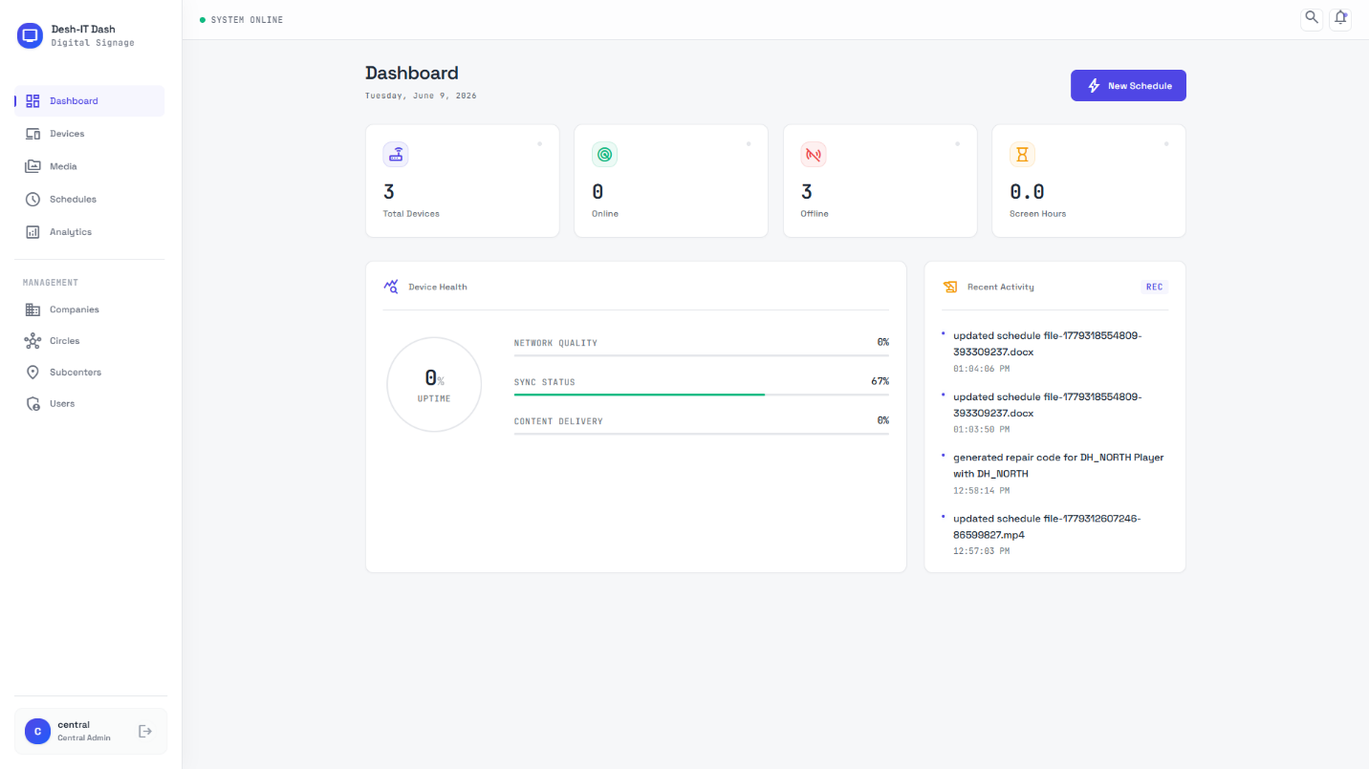
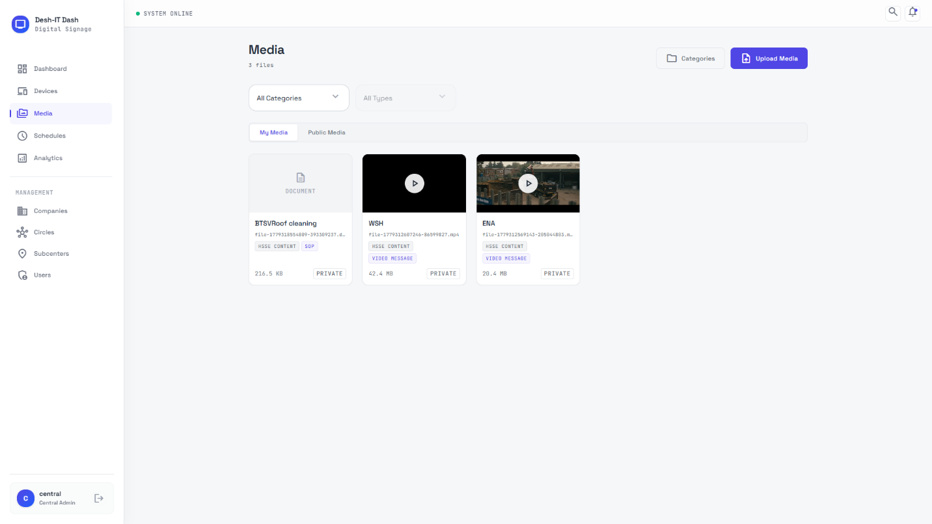
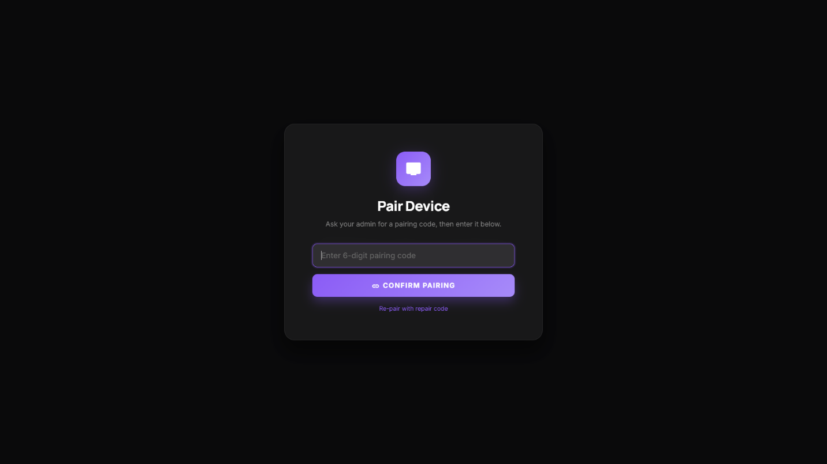

Key Features:
- Web-Based CMS (Central portal for administrators to upload media, build playlists, schedule content, and monitor device health)
- Display Endpoints (Android TVs at subcenters acting as digital receivers with offline caching and kiosk mode operation)
- Unattended 24/7 Operation (Enterprise digital signage must operate continuously without human intervention. Native apps provide automated recovery, kiosk mode, and offline resilience required for mission-critical deployments)
- Hierarchical Content Priority System
  - Central Override-Tier1 (Emergency alerts, live feeds, or mandatory daily broadcasts from Central Admin. Instantly interrupts and pauses any currently playing local content)
  - Circle Scheduled-Tier2 (Routine corporate content pushed from Circle to specific or all subcenters. Scheduled broadcasts that play when no Tier 1 content is active)
  - Local Content-Tier3 (Subcenter-specific content (e.g., local Toolbox Talks, safety images). Plays only when no Tier 1 or Tier 2 content is active)

